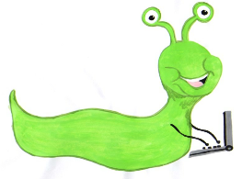 | Lyng Primary School Knowledge Organiser  Computing |  | 
Topic: Computing | How can I use a computer to make art? | Year 1 | Spring 2


What Goldilocks and Step On words will I use?
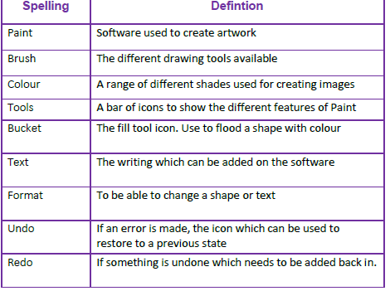
Aims of this unit
To use technology purposefully to create, organise, store, manipulate and retrieve digital content.
- ➢ Colours
- ➢ Brushes
- ➢ Shapes and fill
- ➢ Undo and redo
- ➢ Text
- ➢ Making a poster
Safeguarding
Filtering and monitoring system is in place. Children will use their own log in details to track any misuse and to protect the child from harmful websites and pop ups. Children will be reminded of how to stay safe online and to use technology safely and respectfully and to tell a trusted adult if there is anything on their computer that makes them uncomfortable.

Outcomes
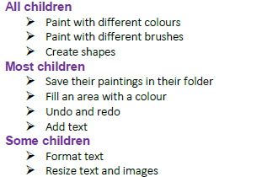
Spring Term
Painting and Digital Images

In this unit…
Children will learn basic painting skills in a painting application on a computer or tablet device. Children will use a simple painting program to paint with different colours and brushes, create shapes, fill areas, undo and redo and add text.
Agreed outcome
Create a poster to showcase their topic learning.
:

